USEFUL INFORMATION ON İSTANBUL AND

BOĞAZİÇİ UNIVERSITY CAMPUSES

Some remarks:

* Taxis are yellow colored, and are easy to identify.
* Public buses are in various colors, bus means “otobüs” in Turkish,
* HAVAŞ is the name of the bus from the airports to downtown,
* “Dolmuş” in Turkish means “ it is filled”, it is a cheap way of transportation in cities. It is something between a taxi and a public bus. They have specific routes (runing free from schedules ), They take off whenever there are “enough “ passengers. They have certain stops, but you can also ask to get off at almost where you want.
*The prices and the trip durations stated below may not be exact, they are approximate!
*There may be drastic traffic jams in Istanbul.
*SOUTH Campus is the MAIN Campus of Boğaziçi University.
* Istanbul Atatürk Airport (IST) and Boğaziçi University South Campus (and several others) are on the European side of İstanbul.
*Sabiha Gökçen International Airport (SAW) is on the Asian side of Istanbul.
*Kennedy Lodge, Guest House No: 5, IMBM (Istanbul Center for Mathematical Sciences) are in the South Campus of Boğaziçi University.
*We do not normally drink tap water in Istanbul !

This leaflet contains information on:
. Currency
. General information about transportation in Istanbul
. Directions from airports to

Boğaziçi University South Campus,
Istanbul Atatürk Airport (IST),
Sabiha Gökçen Airport (SAW).

. On Boğaziçi University Campus: Campus Maps, directions to lodging options:

Note that LECTURE HALL and REGISTRATION DESK are both in the
FACULTY of SCIENCES BUILDING labelled as # 13 on the campus maps
(in the Turkish version, and the English version, both are in the following pages.)

Dormitory no:4 (Dormitory means “Yurt” in Turkish.) ,
IMBM (Istanbul Center for Mathematical Sciences),
Kennedy Lodge,
Guest House no:5.

. Internet Access
. Where and what to eat near the university?

1
Currency
The currency in Turkey is Turkish Lira, denoted by TL. Divide the price in Turkish Liras by 2 to convert it to Euros and by 1,5 to convert to US Dollars.

General information about transportation in Istanbul
İstanbul is a very large city however it has an extensive public transportation network. The fare for transportation is low.
Getting from one place to the other may take long. Do not get intimidated, be patient.
Depending on the route you choose, you will either take a metro, a Metrobüs, a bus, a dolmuş (see the top of the page for the description of it) , a HAVAŞ shuttle, a taxi or several of these.
Here are some general tips:
* You can pay the fare on a bus. It costs normally 1,50-1,70 Liras (0,75-0,85 Euros) unless otherwise stated .
* However you must buy a token for a metro and for a Metrobüs in advance which costs 1,50 Liras.
* You may by an electronic card/ticket ELBİL which consists of 5 tickets and costs 7,50 Liras.
* Be aware that you cannot buy an ELBİL on a bus.
* Although there is a transfer discount, that does not apply if you pay on the bus or if you use an ELBİL.
* Taxis are usually trustworthy. Yet always make sure that the taxi driver turns the meter on.
*Take taxi rather than public transportation to make any ease trip easier. Because you need combination of various tranportation means. Bus, boat, bus etc.
How to get to Boğaziçi University South Campus ?
- from İSTANBUL ATATÜRK AIRPORT (IST) -- This airport is on the
European side as well as Boğaziçi University. There are various ways to get to the campus.

1) TAXI (easy, cheap if you are several people): Go out of the arrival hall. In front of the building take one of the (yellow) taxis.
Tell the driver that you want to go to “Boazitchi Üniversitesi Ghünei Kampüs” (read all the letters). It takes around 45 minutes to get to the campus and costs 35-45 Liras (18-22 Euros).

2) HAVAŞ + BUS (convenient): Go out of the arrival hall. In front of the building take the shuttle bus called HAVAŞ to Taksim. It costs 10 liras (5 Euros). It takes around 30-45 minutes to reach Taksim, which is the last stop. Where you get off is shown in the
Map 1 marked with a red circle on top of the map . Go to the green circle. Take the bus 559C which goes to Rumelihisarüstü. You can pay on the bus. A ticket costs 1,5 Liras. Tell the driver to drop you off at the gate of the South Campus (say Ghünei Kampüs).
It takes around 30 minutes to get there.

3) METRO + METROBÜS + BUS (fast, cheapest): Follow the METRO signs in the airport. This is the first stop of the metro.
You must buy a token or an ELBİL of 5 tickets. Take the metro and get off at the third station, Ataköy-Şirinevler. This trip takes several minutes. Then change to Metrobüs. This is nothing but a bus on a dedicated track. Take number 34 going to Zincirlikuyu. You can pay on the bus. A ticket costs 1,5 Liras. Get off in Zincirlikuyu, the last stop. It takes around 40 minutes
to get there. Follow the signs that reads Sarıyer. Up the stairs there are several bus stops. Take the bus 559C which goes to Rumelihisarüstü. Tell the driver to drop you at the gate of the South Campus (say Ghünei Kampüs). It takes around 15 minutes to get there.
2
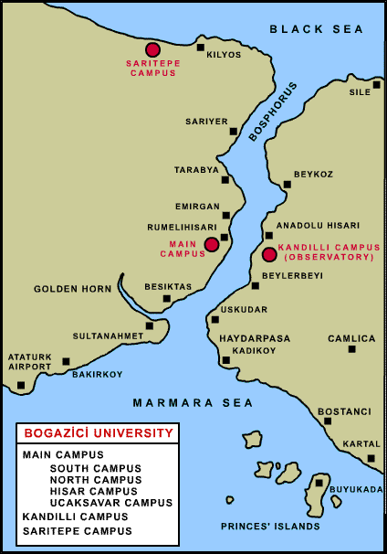

The above map is the general outlook of the Bosphorus showing Ataturk Airport (IST) and Boğaziçi University campuses.

- From SABIHA GÖKÇEN INTERNATIONAL AIRPORT (SAW)
This airport is on the Asian side while the university is on the European side. Options are:
1) BUS + TAXI: Go out of the arrival hall. In front of the building take the bus number E3.
It reads Sabiha Gökçen Havalimanı-4. Levent Metro. You can pay on the bus. A ticket costs 4,5 Liras. You will get off at the last stop. The trip takes more than an hour and even more depending on the traffic. On the way you will pass across Bosphorus. As soon as you get off
from the bus, use the underground passage to get across the street. At the other side take a (yellow) taxi. Tell the driver to take you to “Boazitchi Üniversitesi Ghünei Kampüs” (read all the letters). It takes around 15 minutes to get to the campus and costs around 10 Liras (5 Euros).

2) HAVAŞ + TAXI: Go out of the arrival hall. In front of the building take the shuttle called HAVAŞ to Taksim. It costs 13 Liras (6,5 Euros). Get off at Kavacık. The trip takes nearly an hour and even more depending on the traffic. After getting off, take a (yellow) taxi which will go in the same direction as the shuttle and eventually pass across Bosphorus. Tell the driver to take you to “Boazitchi Üniversitesi Ghünei Kampüs” (read all the letters). It takes around 15 minutes to get to the campus and costs around 15 Liras (7,5 Euros).

3
Map 1.

Please refer to the site for information related to the Boğaziçi Campus http://www.boun.edu.tr/site_map/index.html

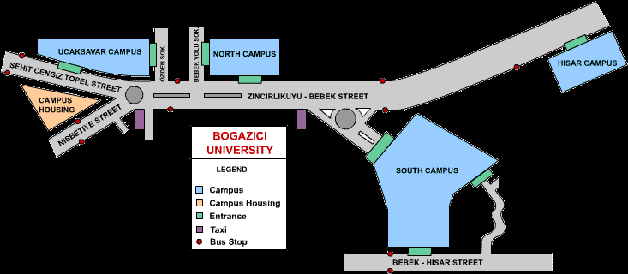

Boğaziçi University Campuses are shown above.

How to get to Dormitory no:4?
This building is situated in the North campus. Once you reach the main gate of the South Campus, follow the orange route shown in the Map 2. You may ask your way to the gate keepers of the North Campus. Tell that you are going to Dördüncü Yurt (pronounce Dördündjü Yurt, read all letters).

4
How to get to IMBM (Istanbul Center for Mathematical Sciences)?
IMBM is situated in Boğaziçi University campus. Follow the red path in Map 3 to reach the IMBM from the main entrance of the South Campus.

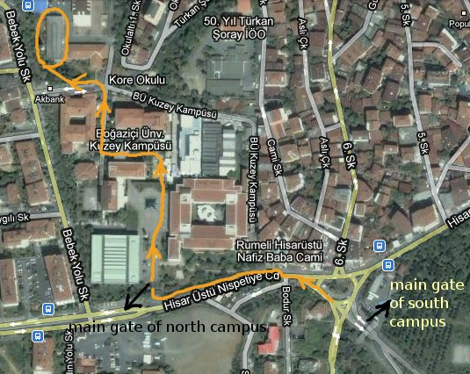
Map 2. Orange path on Map 2 takes you from South Campus to Dormitory 4 (next to Dormitory 3 in the circle on top of the map).

Map 3.

5
http://www.boun.edu.tr/map/campus_mapsnew.htm has the Campus Map given below. You can print in a big scale for better readibility, the map given at the end with markings is the larger version of the map below in Turkish.

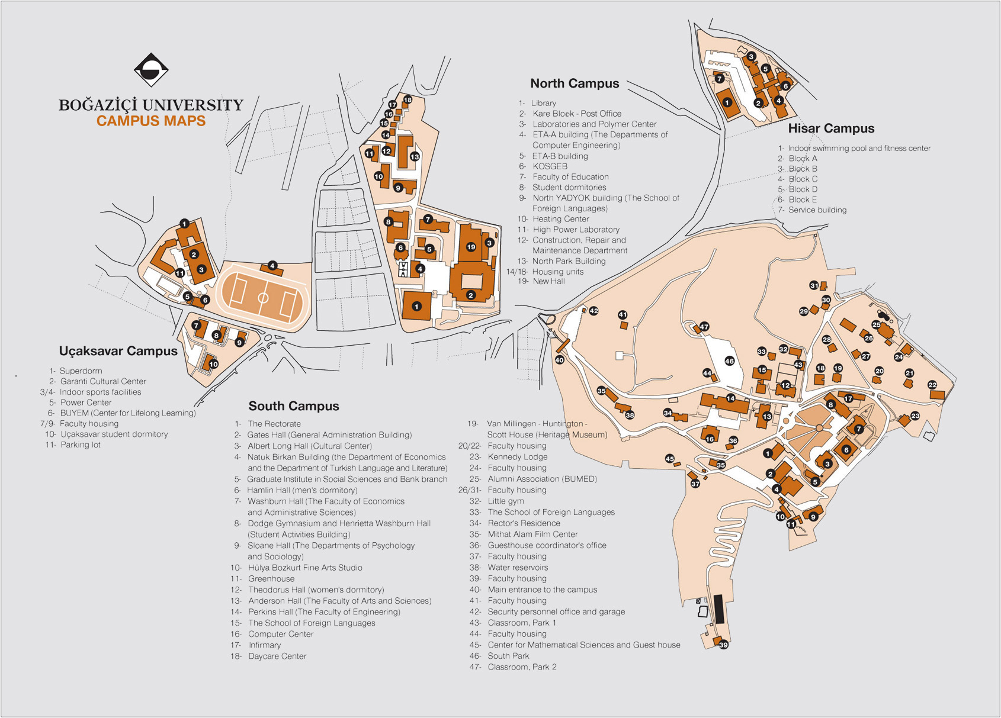
How to get to Kennedy Lodge and Guest House no:5
Both are in the South Campus. Kennedy Lodge is marked with the orange circle while Guest House no: 5 is marked with the white circle in Map 3.
On the white path there are stairs. You may ask your way to the gate keepers of the Campus.

How to get to various places from Boğaziçi University Campus?
Bus Lines passing by Boğaziçi University

43R | RUMELİ HİSARÜSTÜ - KABATAŞ
59R | RUMELİ HİSARÜSTÜ - ŞİŞLİ
59RS | RUMELİHİSARÜSTÜ - SARIYER  6
125 | KADIKÖY - BOĞAZİÇİ ÜNV-R.HİSARÜSTÜ
559C | RUMELİHİSARÜSTÜ - TAKSİM
From the site http://www.library.boun.edu.tr/iletisim.php#kroki you can get lots of information on these bus lines by clicking on each one.

From http://www.boun.edu.tr/site_map/index.html it is possible to get many maps etc.

Taksim: Take bus no 559C, Taksim is the last stop. Take the same bus line on the way back from Taksim. Buses run until 23:25.
Taxi costs about 20-25 Liras.
Another way to go Taksim: Walk down to Bosphorus. Take a bus to Taksim. This route is nicer but might get very slow depending on the traffic.
Beşiktaş: Take bus no 559C or 43R, get off at Beşiktaş where the route meets Bosphorus the first time.
Kadıköy: First go to Beşiktaş as described above, then walk down towards Bosphorus . You should be near Beşiktaş Wharf (Beşiktaş Iskelesi )take a boat going to Kadıköy.
Kadıköy is one of the main centers of the Asian side of Istanbul.
From the Beşiktaş Wharf there are commuter boats running every quarter past and quarter to the hour to cross the Bosphorus ( to change continents!).
Last boat from Kadıköy to Beşiktaş is 20:45. There are later boats to European side, though ,
between Üsküdar – Beşiktaş .
Furthermore, there is dolmuş (see the top of the page for its description) from Kadıköy to Taksim 24 hours.
These boats are very very cheap, about 1 Euro. It is highly recommended to get on these boats just to enjoy a very pleasant trip on the Bosphorus. It is fun to watch the sea gulfs flying by the boat during trip and seeing people to feed them while they are flying!.
Some boats are privately run as opposed to the official ones (we suggest the official ones).
There is tea, coffe, refreshments on the big ones.

Internet Access

In Kennedy Lodge there is internet access , in the Hotel La Villa Blanche there is wireless inter service for the hotel customers free of charge.

In the building IMBM , Istanbul Center for Mathematical Sciences,
(approximately 5 minute walking distance to the lecture halls where the talks will be held, marked as the red circle on Map 3) there are two computers you can use them for e-mail.

In addition, from the site http://www.cc.boun.edu.tr/faq.html#19a we copied the following information. For more information you can visit that site.

Is There Wireless Laptop Network Connectivity On Boğaziçi University Campuses?

Yes, this service is available in;
South Campus: Teras Canteen, Rectorate Building, Engineering Faculty Building Roof, Engineering Faculty Building 3rd floor
North Campus: Library and Science and Engineering Laboratory Building Chemical Engineering Classroom.
7
How do I get my computer connected to the network from my Dormitory?
There's Internet connection in all dormitories in Boğaziçi University which also
enables you to connect to the dormitory network.
All you need is a computer with Ethernet adapter.

What do I need for a wireless connection?
In order to use wireless ethernet connection you neeed a computer with a wireless ethernet adapter. If you will buy a new adapter, we advise you to buy Cisco, because the nodes that we have are Cisco and a Cisco wireless ethernet adapter directly capture their nodes while others need to be configured according to their software requirements.
For a working wireless connection you need to be at a maximum 50 meter direct distance from a wireless connection node. Your wireless network adapter must be inserted and configured correctly according to its manual. Your computer TCPIP configuration must be all automatic mode.It is your responsibility to configure your wireless adapter.

Where and what to eat near the University?

*Note that we do not normally drink tap water in Istanbul.

*Please refer to Campus Map at the end with markings to find the mentioned restaurants/cafes .

South Campus: There are several canteens in South Campus selling fast food.

Orta Kantin (marked A) is open till the evening. It has good coffee. Another shop where you can have good coffee is marked B.

Rumelihisarüstü:

Ekin Kafe (marked D) serves home made dishes and breakfast. It has ve vegetarian meals. Open from 9:00 till 22:00.

Boluca (marked E) serves home made dishes. It has vegetarian meals.
Open from morning till 21:00.

Dalyan Balık (marked F) serves fish (depending on availability).
There is another fish restaurant marked K.

Hazal Ana (marked C) is a nice kebap and pide restaurant. Open till late night.

Hisar Üstü Börekçisi (marked G) serves fast food such as börek, tea, ayran.
Open 24 hours.

Hisar:
Çapa Restaurant (marked H) serves cheap fish sandwich and beer by the Bosphorus.
To reach there, go down to Boshorus via the path marked H in the map ; walk down to the sea. The Hisar district is where you reach the sea.
8
